LOGISTICS DATA ANALYST INTERNSHIP
WEEK 3 — ADVANCED DATA ANALYSIS AND VISUALIZATION
TwoWheel Express — Thane–Mumbai Last-Mile Logistics
Prepared by: Pratik Khose
MBA in Data Science and Business Analyst

1. Week 3 Objective
Week 3 builds directly on the cleaned and normalized TwoWheel Express dataset prepared in Week 2. The purpose is to perform exploratory data analysis, calculate descriptive statistics and correlations, visualize logistics performance, identify cost drivers and operational bottlenecks, and provide practical recommendations.

2. Continuity from Week 2
Week 2 addressed missing values, duplicate order records, inconsistent categorical labels, outliers, timestamp errors, unit consistency, and feature scaling. The cleaned dataset was prepared for the exploratory analysis planned for Week 3. This report therefore keeps the same TwoWheel Express scenario and Week 2 variable structure.

3. Exploratory Data Analysis
The analysis examines delivery time, distance, order weight, promised delivery time, on-time performance, operating cost, traffic, vehicle type, weather, and zone.
import pandas as pd
import matplotlib.pyplot as plt
import seaborn as sns
df = pd.read_csv("week2_cleaned_logistics.csv")
print(df.info())
print(df.describe())
print(df.groupby("zone")["delivery_time_min"].agg(["count","mean","median"]))
print(df.groupby("vehicle_type")["operating_cost"].mean())
print(df.groupby("traffic_level")["delivery_time_min"].mean())

4. Descriptive Statistics and Central Tendency
Mean, median, standard deviation, minimum, quartiles and maximum were used to understand the central tendency and spread of the numerical logistics measures.
Measure | Count | Mean | Median | Std. Dev. | Max
distance_km | 1200 | 6.02 | 5.3 | 3.55 | 15.0
order_weight_kg | 1200 | 3.19 | 3.09 | 1.61 | 8.8
delivery_time_min | 1200 | 31.6 | 31.3 | 10.07 | 60.0
promised_time_min | 1200 | 34.63 | 33.5 | 5.68 | 49.0
operating_cost | 1200 | 28.48 | 26.02 | 12.5 | 68.67

5. Delivery Time Distribution
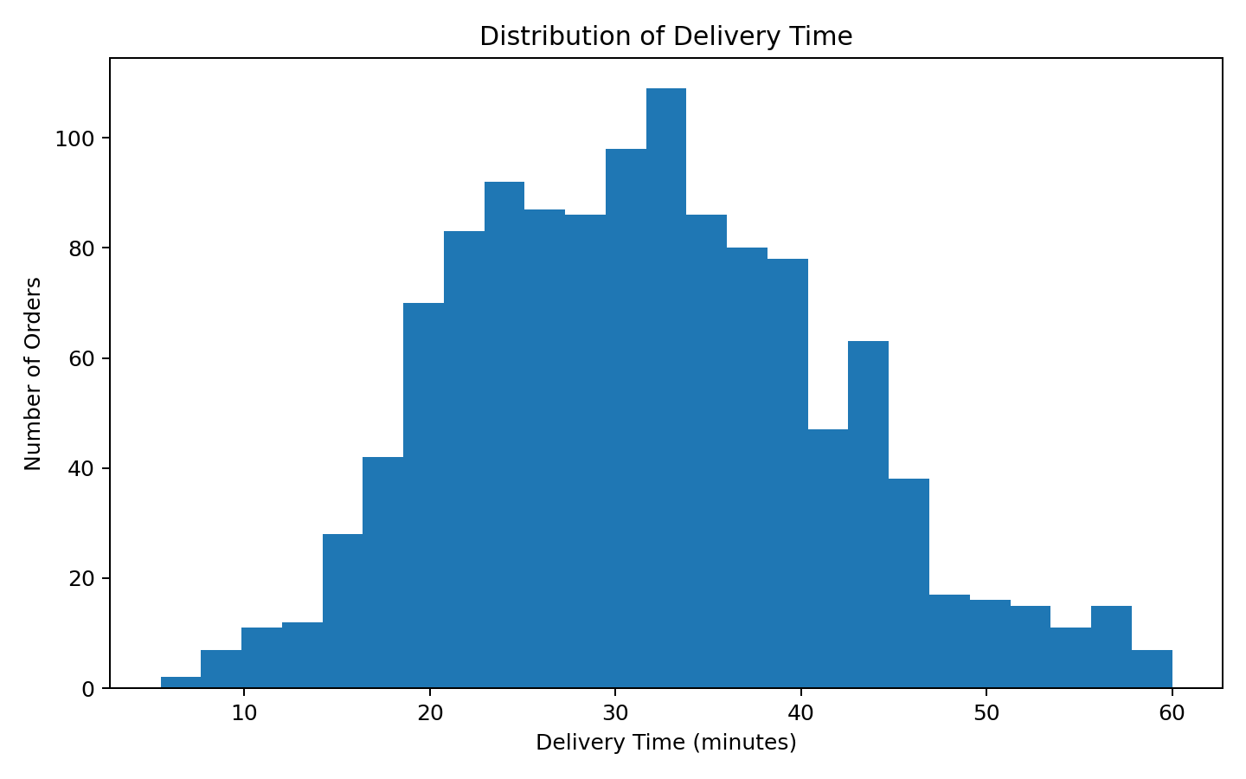
The histogram shows the distribution and spread of delivery durations and helps identify the typical operating range and long-delay tail.

6. Distance vs Delivery Time
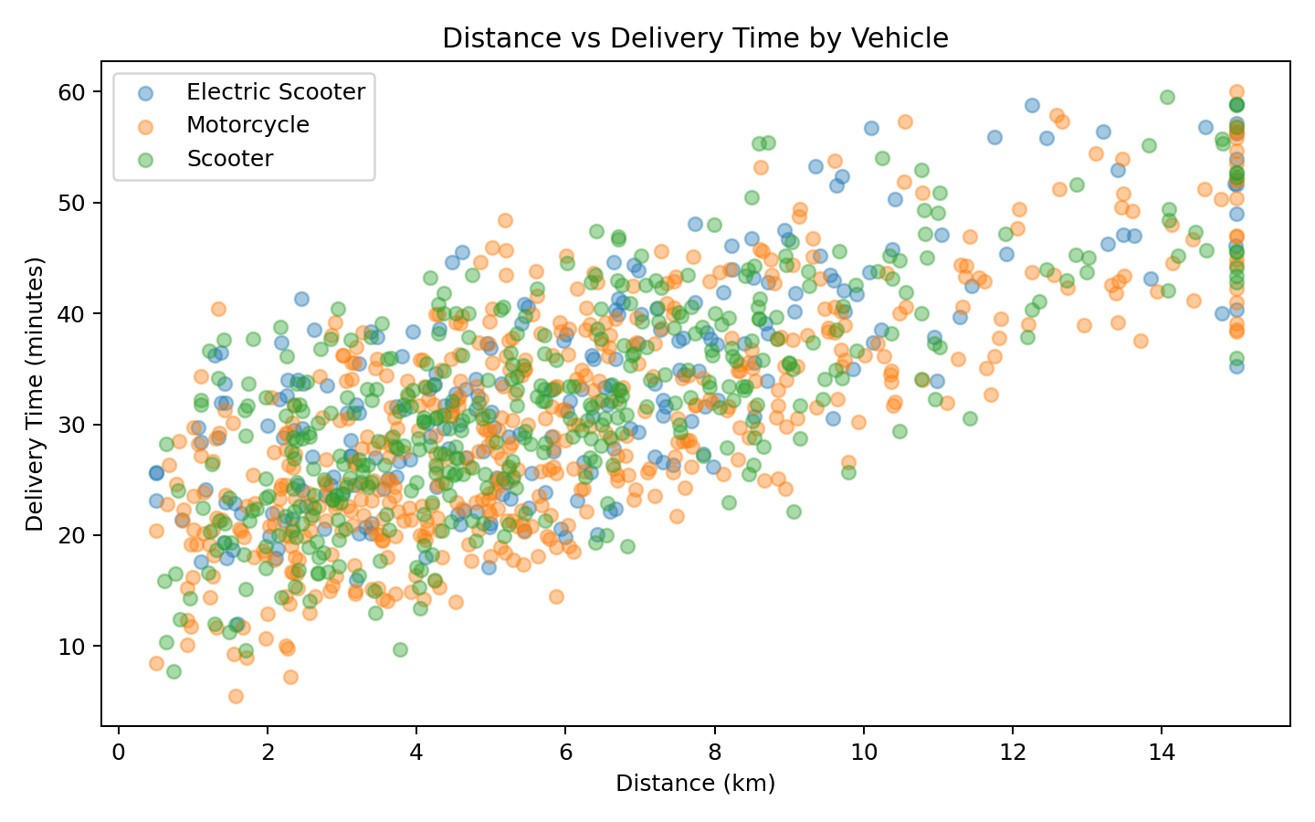
The scatter plot examines the relationship between trip distance and delivery duration while separating vehicle types.

7. Delivery Time by Traffic Level
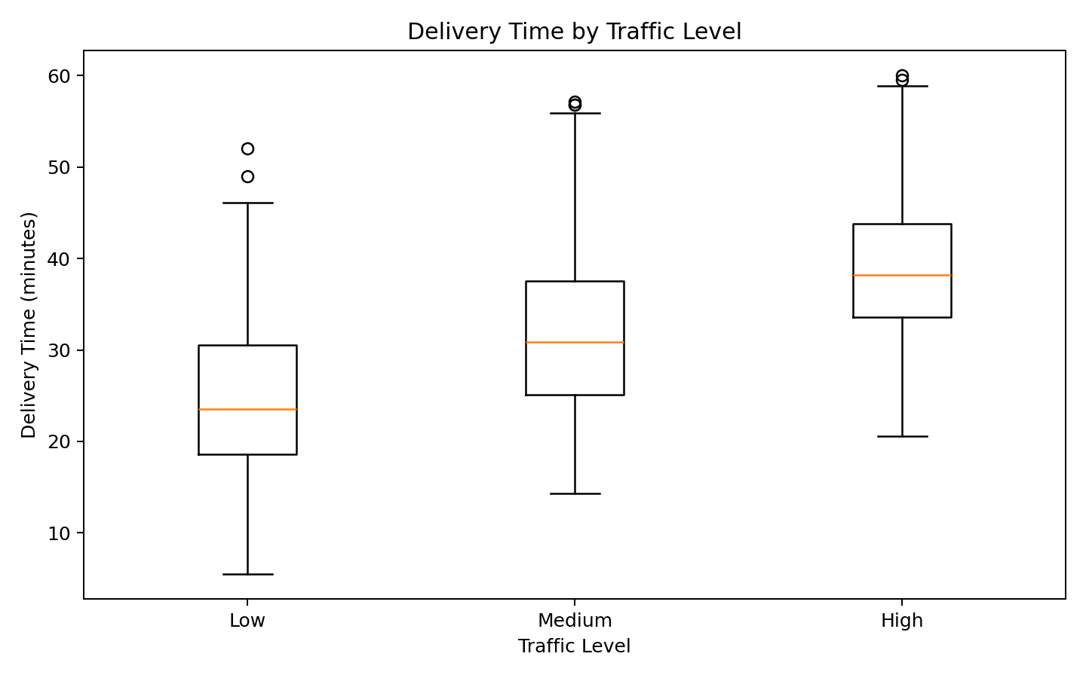
The boxplot compares median, spread, and extreme delivery times across low, medium, and high traffic.

8. Correlation Analysis
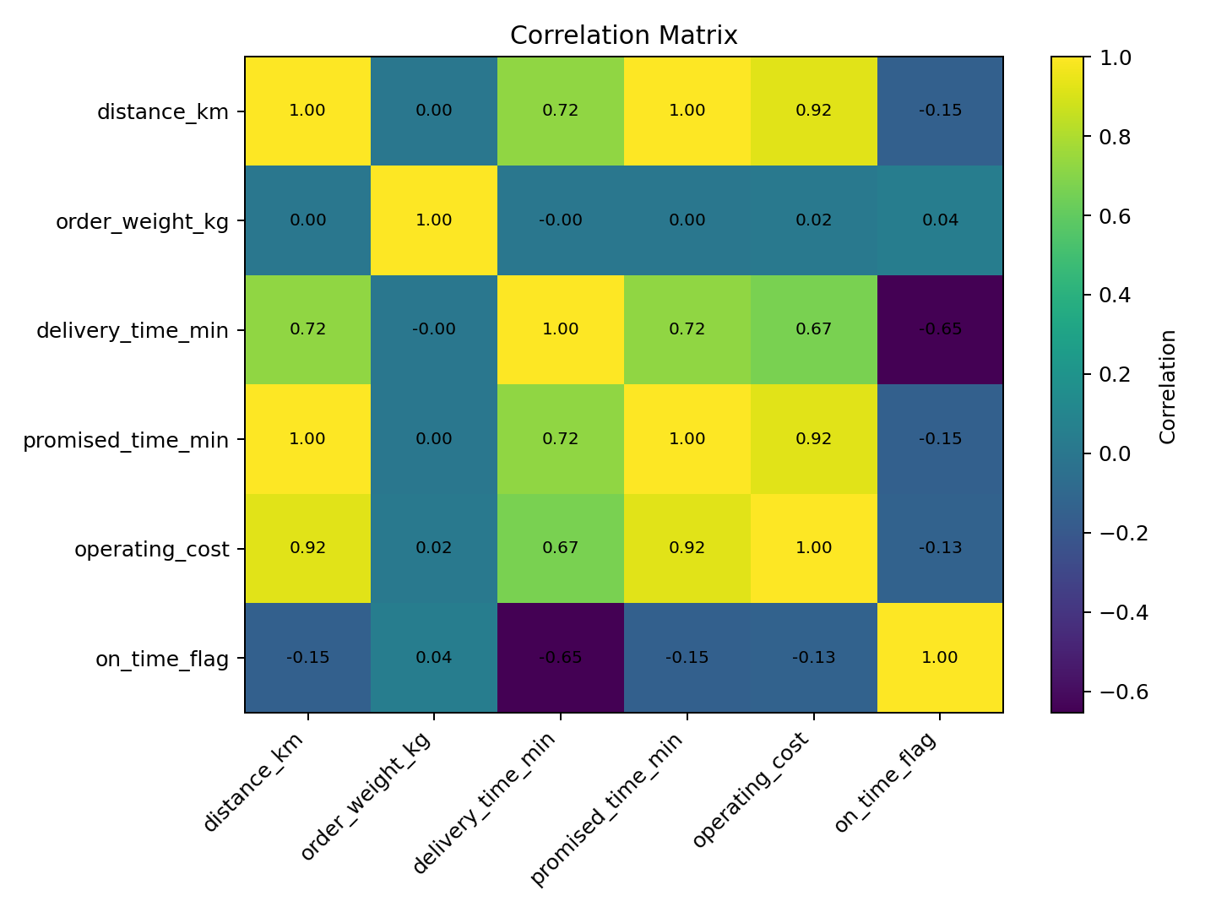
The correlation matrix summarizes linear relationships among numerical logistics variables and helps identify candidates for later predictive modelling.

9. Transportation Cost by Vehicle Type
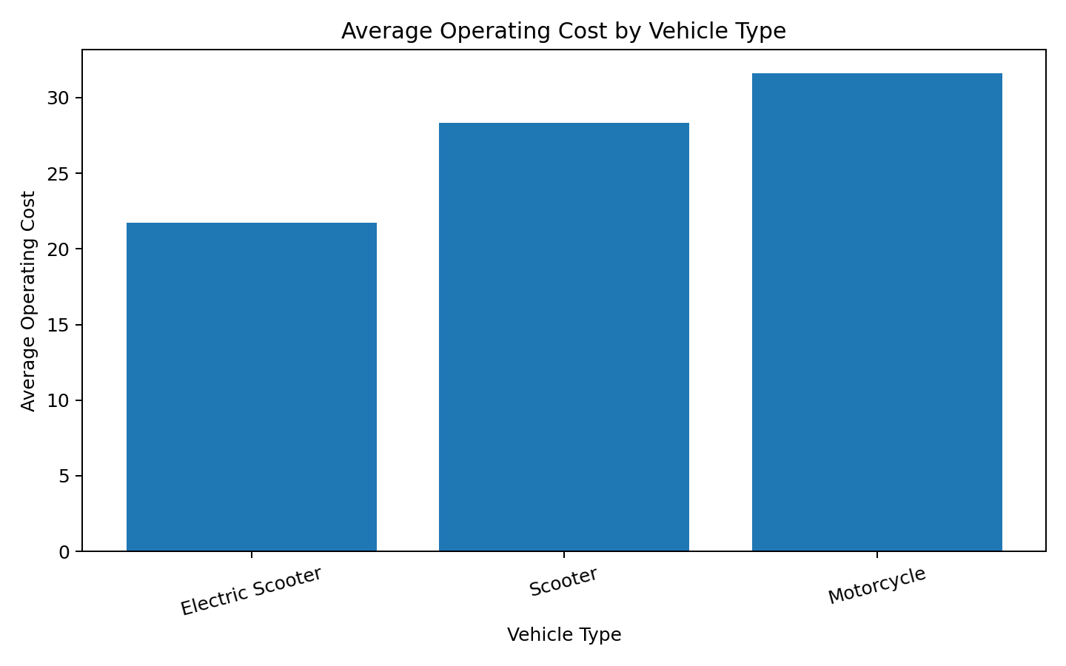
The bar chart compares average operating cost across the fleet and supports vehicle-mix and cost-driver analysis.

10. Shipment Volume by Zone
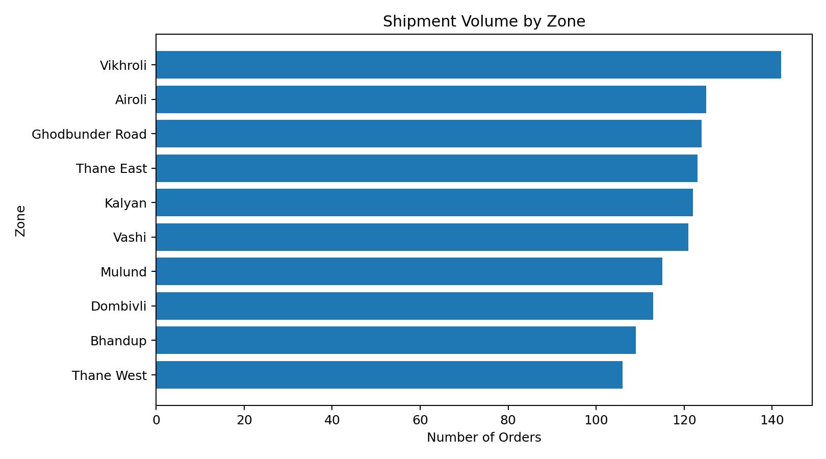
The chart compares order volume across operating zones and supports hub capacity and rider allocation decisions.

11. Logistics Performance Insights
- Delivery time increases as trip distance increases, making distance an important operational driver.
- High-traffic conditions are associated with longer and more variable delivery durations, indicating a congestion bottleneck.
- Vehicle type affects operating cost, making fleet mix an important cost consideration.
- Shipment volume differs by zone, so rider and hub capacity should be compared with zone-level demand.
- On-time delivery should be evaluated together with promised time, delivery time, traffic, and distance.
- The correlation results provide a starting point for selecting features for Week 4 predictive modelling.

12. Operational Recommendations
- Use traffic-aware dispatch planning during high-congestion periods.
- Review high-volume zones for rider and micro-hub capacity alignment.
- Compare vehicle operating cost with distance and delivery performance before changing fleet mix.
- Prioritize zones where high shipment volume is combined with weaker delivery performance.
- Use Week 3 findings as business context and candidate features for Week 4 predictive modelling and optimization.

13. Python Code for Visualizations
# Delivery-time distribution
sns.histplot(df["delivery_time_min"], bins=25, kde=True)
plt.title("Distribution of Delivery Time")
plt.show()
# Distance vs delivery time
sns.scatterplot(data=df, x="distance_km", y="delivery_time_min",
hue="vehicle_type")
plt.title("Distance vs Delivery Time by Vehicle")
plt.show()
# Traffic effect
sns.boxplot(data=df, x="traffic_level", y="delivery_time_min")
plt.title("Delivery Time by Traffic Level")
plt.show()
# Correlation
corr = df.select_dtypes(include="number").corr()
sns.heatmap(corr, annot=True, fmt=".2f")
plt.title("Correlation Matrix")
plt.show()
# Cost driver
df.groupby("vehicle_type")["operating_cost"].mean().plot(kind="bar")
plt.title("Average Operating Cost by Vehicle Type")
plt.show()
# Shipment volume
df["zone"].value_counts().plot(kind="bar")
plt.title("Shipment Volume by Zone")
plt.show()

14. Conclusion
Week 3 extends the Week 2 data-preparation work into analysis and visualization. The results show how delivery time, distance, traffic, vehicle type, shipment volume, and operating cost interact within the TwoWheel Express operation. The visualizations provide evidence for operational recommendations and create the analytical foundation for Week 4 predictive modelling and optimization.
and optimization techniques can be applied to forecast performance and evaluate improvement strategies.

